Company Analyst Report

**Corporate Finance: 07 14512**

Company: BAE Systems

Group Members:

Robert Jones 1023075

Gurpreet Ubbey 101

Mark Sandberg

Ying Deng

Khaleel Chaundry

Anthony Kwabena Opoku

**Principle activities**

BAE Systems plc. is a British multinational defence, security and aerospace company headquartered in London, United Kingdom and with operations worldwide. It is among the world's largest defence contractors. Its largest operations are in the United Kingdom and United States, where its BAE Systems Inc. subsidiary is one of the six largest suppliers to the US Department of Defence. Other major markets include Australia, India and Saudi Arabia.

BAE Systems is the successor to various aircraft, shipbuilding, armoured vehicle, armaments and defence electronics companies. BAE Systems is involved in several major defence projects, including the F-35 Lightning II, the Eurofighter Typhoon, the Astute-class submarine and the Queen Elizabeth-class aircraft carriers.

List of customers: The Marconi Company, the first commercial company devoted to the development and use of radio; A.V. Roe and Company, one of the world's first aircraft companies; de Havilland, manufacturer of the world's first commercial jet airliner; British Aircraft Corporation, co-manufacturer of the Concorde supersonic transport; Super marine, manufacturer of the Spitfire; Yarrow Shipbuilders, builders of the Royal Navy's first destroyers; and Vickers Shipbuilding and Engineering, builders of the Royal Navy's first submarines.

**Main products:**

Defence

Security

Electronics & Systems Integration

Cyber & Intelligence

Military & Technical Services

IT & Information Systems

Consultancy Services

Major developments list:

* **On 7 May 2007 BAE announced its subsidiary BAE Systems Inc. was to purchase Armour Holdings for £2.3 billion (approx. US$4.5 billion c. 2007) and completed the deal on 31 July 2007.**

**---------expect rise in graph**

* **The UK Ministry of Defence awarded BAE a 15-year munitions contract in August 2008 worth up to £3 billion.**

**--------- expect rise in graph**

* **In February 2010 BAE announced a £592 million write-down of the former Armour Holdings business following the loss of the Family of Medium Tactical Vehicles contract in 2009.**

**--------- expect downtrend in graph (from late 2009 till Feb 2010)**

* **BAE continued its move into support services in May 2010 with the purchase of the marine support company Atlantic Marine for $352 million**.

**--------- expect rise in graph**

* **In September 2011, BAE Systems began consultation with unions and workers over plans to cut nearly 3,000 jobs, mostly in the company's military aircraft division.**

**--------- expect downtrend in graph**

**Analysing the cash flow statement**

A cash flow statement breaks down how a company raised funds and spent those funds. It is generally separated into 3 sections, Operations, Financing and investing. As a rule if a company brings in enough money to cover its expenses then it is doing well. One of the most important things when looking to invest in a company is said company’s ability to generate enough cash to cover its expenses. Even if a company is displaying profits on the income statement, this might not necessarily translate into cash that can be used to balance bills and outgoing payments.

For the year ended 31 December

|  | **2011 £m** | **2010 £m** |
| --- | --- | --- |
| Profit for the year | 1,256 | 1,081 |
| Taxation expense | 211 | 417 |
| Share of results of equity accounted investments | (131) | (133) |
| Net finance costs | 117 | 192 |
| Depreciation, amortisation and impairment | 751 | 899 |
| Profit on disposal of property, plant and equipment | (17) | (13) |
| Profit on disposal of investment property | (21) | - |
| Loss/(profit) on disposal of businesses | 15 | (53) |
| Cost of equity-settled employee share schemes | 68 | 58 |
| Movements in provisions | (148) | 101 |
| Decrease in liabilities for retirement benefit obligations | (287) | (452) |
| (Increase)/decrease in working capital: |  |  |
| Inventories | (85) | 318 |
| Trade and other receivables | 191 | 183 |
| Trade and other payables | (969) | (1,063) |
| **Cash inflow from operating activities** | **951** | **1,535** |
| Interest paid | (212) | (221) |
| Taxation paid | (257) | (352) |
| **Net cash inflow from operating activities** | **482** | **962** |
| Dividends received from equity accounted investments | 88 | 71 |
| Interest received | 32 | 48 |
| Income from financial assets at fair value through profit or loss | 4 | - |
| Purchases of property, plant and equipment, and investment property | (359) | (408) |
| Purchases of intangible assets | (24) | (19) |
| Proceeds from sale of property, plant and equipment, and investment property | 115 | 70 |
| Purchase of subsidiary undertakings (net of cash acquired) | (532) | (179) |
| Purchase of equity accounted investments | - | (2) |
| Equity accounted investment funding | (1) | (7) |
| Proceeds from sale of subsidiary undertakings (net of cash disposed) | 124 | - |
| Proceeds from sale of equity accounted investments | - | 93 |
| Proceeds from sale of financial assets at fair value through profit or loss | 152 | - |
| Proceeds from sale of other investments | 1 | - |
| Net proceeds from sale/(purchase) of other deposits/securities | 265 | (40) |
| **Net cash outflow from investing activities** | **(135)** | **(373)** |
| Capital element of finance lease rental payments | - | (7) |
| Proceeds from issue of share capital | - | 6 |
| Purchase of treasury shares | (503) | (503) |
| Purchase of own shares | (6) | (23) |
| Equity dividends paid | (606) | (574) |
| Dividends paid to non-controlling interests | (22) | (32) |
| Cash outflow from matured derivative financial instruments | (34) | (123) |
| Cash inflow from movement in cash collateral | - | 11 |
| Cash inflow from loans | 2,693 | 1,317 |
| Cash outflow from repayment of loans | (2,541) | (1,576) |
| **Net cash outflow from financing activities** | **(1,019)** | **(1,504)** |
| Net decrease in cash and cash equivalents | (672) | (915) |
| Cash and cash equivalents at 1 January | **2,802** | **3,678** |
| Effect of foreign exchange rate changes on cash and cash equivalents | 6 | 39 |
| **Cash and cash equivalents at 31 December** | **2,136** | **2,802** |
| Comprising: |  |  |
| Cash and cash equivalents1 | 2,141 | 2,813 |
| Overdrafts | (5) | (11) |
| **Cash and cash equivalents at 31 December** | **2,136** | **2,802** |

Above is BAE Systems cash flow statement for the year ending 31st December, and it is alongside the previous year’s cash flow statement as a comparison.

Operations are the cash generated over the year from the company’s core transactions.

Investing is the cash generated from investments outside the core operations.

Financing is the cash movement from financing opportunities, such as Loans, issuance of new stock and dividends.

Free cash flow signals a company's ability to pay debt, pay dividends, buy back stock and facilitate the growth of business

Free cash flow = (Net income + Depreciation) – (Changes in working capital + Capital expenditures)

= (1,256 + 751) – (628 + ?)

Operating cash flow = Net Operating Cash Flow / Cost of Sales = Number of £’s we receive in exchange for every £ of sales

= (482 / 17770) = 0.0271243669105234 = 0.027?

**BALANCE SHEET FINANCIAL RATIOS**

Current Ratio=

$\frac{Current Assets}{Current Liabilities}=\frac{7,625}{12278}=0.$ 62

The current ratio is a measure of the short term liquidity. Therefore our answer of 0.62 means that BAE has its current liabilities covered 0.62 times over. To a firm such as BAE a high current ratio indicates liquidity so a ratio of at least 1 is expected. However, as it is less than one it means that net working capital is negative which is not useful and is very unusual for a firm such as BAE

Quick Ratio =

$\frac{Current Assets-Inventory}{Current Liabilities}=\frac{7,625-856}{12278}=0.$ 55

The quick ratio tells us about a company's stock. Inventory is often the least liquid current asset. It is also the one for which the book values are least reliable as measures of market value, because the quality of the inventory is not considered. A ratio of 0.55 is not a huge difference to the quick ratio which shows as that there is not a large quantity of inventory in the company.

**INCOME STATEMENT FINANCIAL RATIOS**

**Price Earnings Ratio=**

$$\frac{Price per share}{Earnings per share}=\frac{£0.369}{£0.367}=1.005$$

The Price Earnings Ratio shows us the market value measures. Thus, BAE shares carry a price earnings multiple of 1.005. The Price Earnings ratio measures how much investors are willing to pay per unit of earnings, higher Price Earnings are often taken to mean that the firm has significant prospects for future growth. As BAE has a Price Earnings ratio of 1.005 it shows that there is little prospect for growth in this industry.

**Weekly Return Analysis**

|  |  |  |
| --- | --- | --- |
|  | **Mean of Weekly Returns** | **S.D of Weekly Returns** |
| **BAE** | 0.003357145 | 0.038170191 |
| **FTSE 100** | 0.001740051 | 0.024631479 |

The standard deviation of the weekly returns of BAE is greater than the weekly returns of the FTSE 100. This means that since standard deviation of returns is a measure of the risk and therefore the volatility of an investment, BAE stock is riskier than the FTSE 100. However, the investor is compensated for bearing this extra risk, with BAE having a greater mean return than the FTSE 100.

**Regression for BAE Systems**

|  |  |  |  |  |  |  |
| --- | --- | --- | --- | --- | --- | --- |
|  |  |  |  |  |  |  |
| *Regression Statistics* | |  |  |  |  |  |
| Multiple R | 0.606271724 |  |  |  | Things to Analyse |  |
| R Square | 0.367565403 |  |  |  |  |  |
| Adjusted R Square | 0.366334985 |  |  |  |  |  |
| Standard Error | 0.030736307 |  |  |  |  |  |
| Observations | 516 |  |  |  |  |  |
|  |  |  |  |  |  |  |
| ANOVA |  |  |  |  |  |  |
|  | *df* | *SS* | *MS* | *F* | *Significance F* |  |
| Regression | 1 | 0.282218505 | 0.282218505 | 298.7322607 | 4.19912E-53 |  |
| Residual | 514 | 0.485586361 | 0.000944721 |  |  |  |
| Total | 515 | 0.767804866 |  |  |  |  |
|  |  |  |  |  |  |  |
|  | *Coefficients* | *Standard Error* | *t Stat* | *P-value* | *Lower 95%* | *Upper 95%* |
| **Y intercept** | 0.001692041 | 0.001354048 | 1.249616746 | 0.212008284 | -0.000968108 | 0.004352191 |
| **Gradient** | 0.921524605 | 0.053317021 | 17.28387285 | 4.19912E-53 | 0.81677852 | 1.026270691 |

|  |  |
| --- | --- |
| *Lower 95.0%* | *Upper 95.0%* |
| -0.000968108 | 0.004352191 |
| 0.81677852 | 1.026270691 |

Figure 1: BAE Regression against The market

**DISCUSSION**

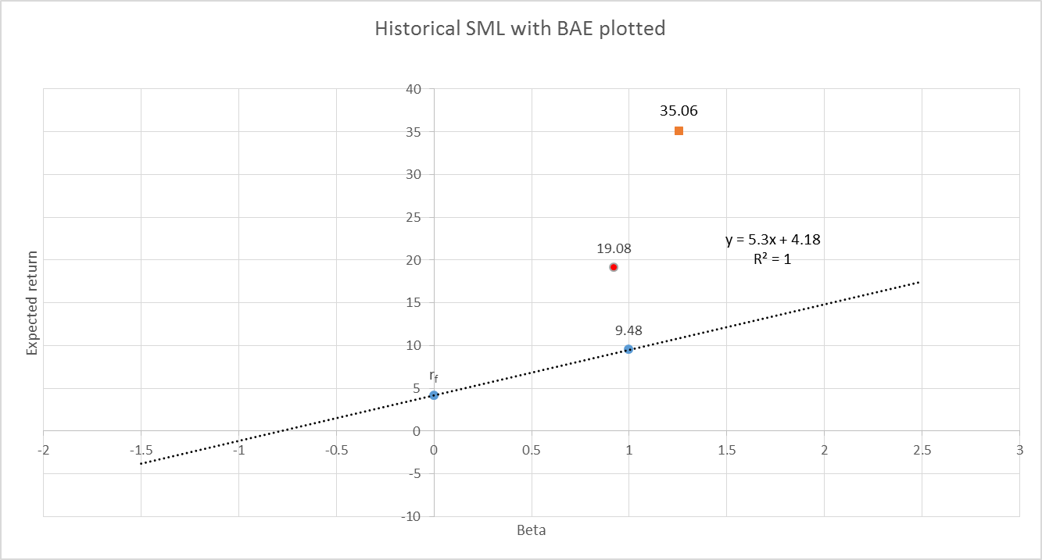

**BAE Historical SML Line**

**DISCUSSION**

**Regression For Rolls-Royce**

|  |  |  |  |  |  |  |
| --- | --- | --- | --- | --- | --- | --- |
| RR regression data |  |  |  |  |  |  |
|  |  |  |  |  |  |  |
| *Regression Statistics* | |  |  |  |  |  |
| Multiple R | 0.681001282 |  |  |  |  |  |
| R Square | 0.463762747 |  |  |  |  |  |
| Adjusted R Square | 0.462719484 |  |  |  |  |  |
| Standard Error | 0.034291143 |  |  |  |  |  |
| Observations | 516 |  |  |  |  |  |
|  |  |  |  |  |  |  |
| ANOVA |  |  |  |  |  |  |
|  | *df* | *SS* | *MS* | *F* | *Significance F* |  |
| Regression | 1 | 0.522716 | 0.522716 | 444.5309 | 1.44E-71 |  |
| Residual | 514 | 0.604404 | 0.001176 |  |  |  |
| Total | 515 | 1.12712 |  |  |  |  |
|  |  |  |  |  |  |  |
|  | *Coefficients* | *Standard Error* | *t Stat* | *P-value* | *Lower 95%* | *Upper 95%* |
| Intercept | 0.003803135 | 0.001511 | 2.517545 | 0.01212 | 0.000835 | 0.006771 |
| X Variable 1 | 1.254143276 | 0.059483 | 21.0839 | 1.44E-71 | 1.137283 | 1.371004 |

|  |  |
| --- | --- |
| *Lower 95.0%* | *Upper 95.0%* |
| 0.000835 | 0.006771 |
| 1.137283 | 1.371004 |

**DISCUSSION**

**Figure 3: Rolls Royce Regression Against Market**

**DISCUSSION**